Our Healing Journey
Our Healing Journey is a three day Indigenous based, family wellness workshop focused on healing the mind, body & spirit through natural therapies, traditional knowledge, music and art to promote positive outcomes creating healthy relationships at home and in the community.

- Healing with Song - the power of music therapy and how it relates to the brain, trauma & healing. Creating positive energy and connecting through music with peers, children and the elderly. Music to calm or energize!
- Living in Balance - Self Care & Wholistic Therapy, Reiki energy work, relaxation & breathing techniques, natural health therapies, healthy living, writing your own story, creating a peaceful environment at home and work.
- Creating and Healing - Therapeutic art projects that encourage self reflection & expression, painting on rocks, canvas to group murals.
- Indigenous Teas – Taste testing and exploring the health benefits and knowledge of harvesting, preparation and storage of wild teas such as Chaga, Wild Mint, Yarrow, Dandelion and Rat Root.
- Positive Choices & Healthy Relationships - Lateral violence prevention, walking with good energy, preventing violent situations & outcomes, mindfulness and motivation for change.
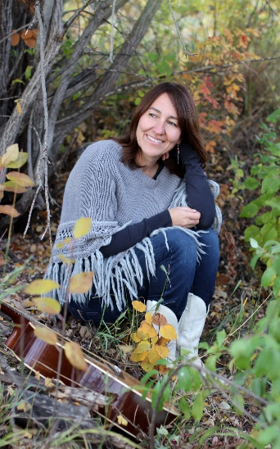
Facilitator
Cindy Paul is an International recording artist and has maintained her career as a registered natural health practitioner, reiki master, licensed practical nurse, certified doula and maternal child health educator. She has a passion for sharing with her community and is an advocate for health & healing through natural therapies, traditional medicines, music, art, and cultural teachings.

